Lab – 1 – Environment Setup

- The objective of this exercise is to have a lab environment from which we can develop and test scripts and ideas as it pertains to DevOps and automation. The following instructions outline a lab configuration that will achieve this goal. The following steps were performed using a Dell Legacy Desktop Computer:
- Install Windows 11.
- Install Oracle VirtualBox.
- Configure Oracle VirtualBox.
- Download Ubuntu ISO.
- In VirtualBox create a VM using the Ubuntu ISO.
- In VirtualBox configure Networks.
- Download VyOS ISO.
- In VirtualBox Create two VMs using VyOS.
- Configure VyOS VMs.
- On the Windows OS install Vagrant.
- Initialize Vagrant to create a VM in VirtualBox.
- On the Ubuntu VM install Ansible.
- Configure Ansible to communicate with the two VyOS servers.
- Configure SSH for Ansible and the two VyOS servers.
- Create our first Ansible Playbook and test. (Playbook YAML file ping_vyos.yaml).
- Lab Completed.
- Requested Screenshots are shown here:
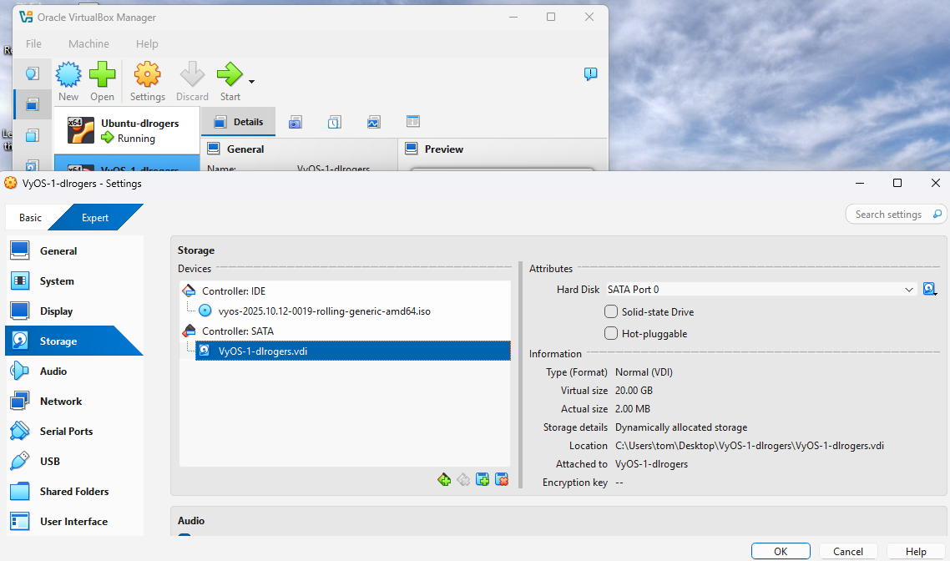
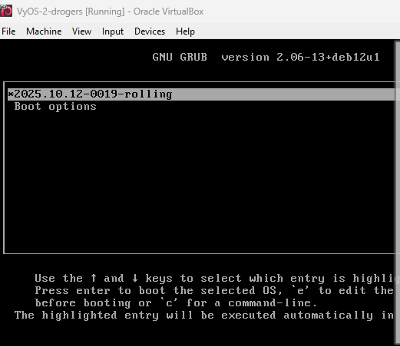
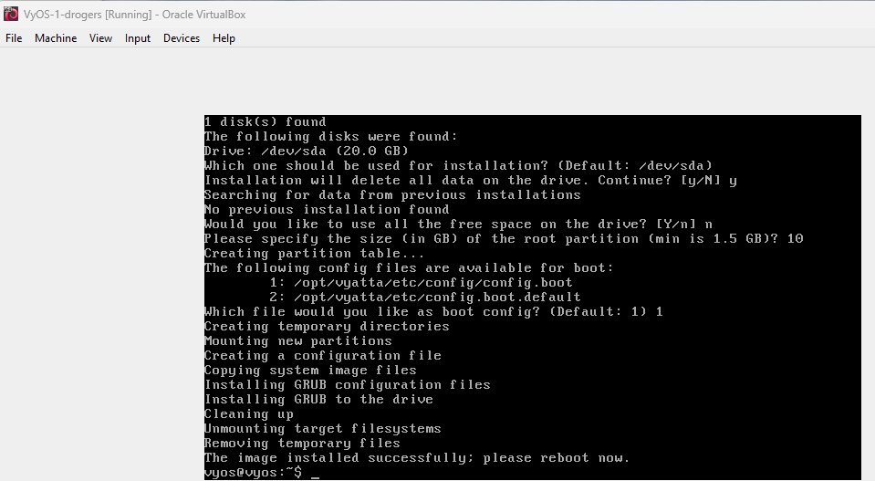
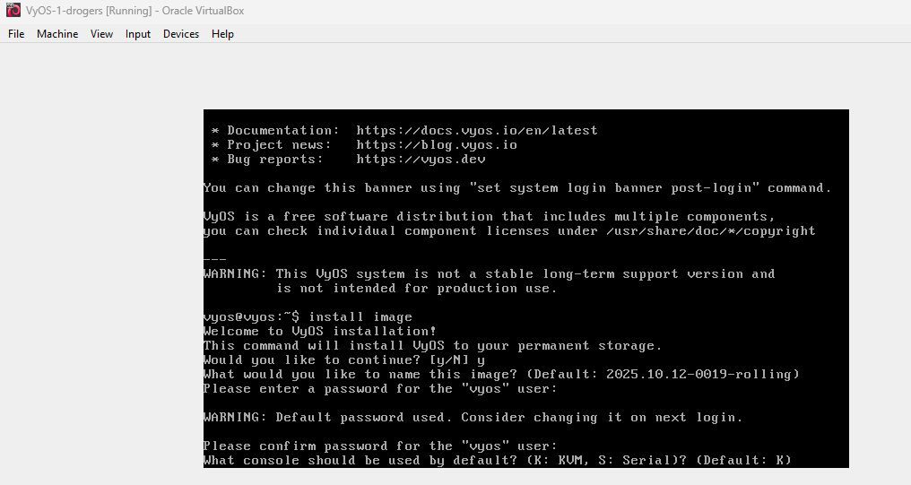
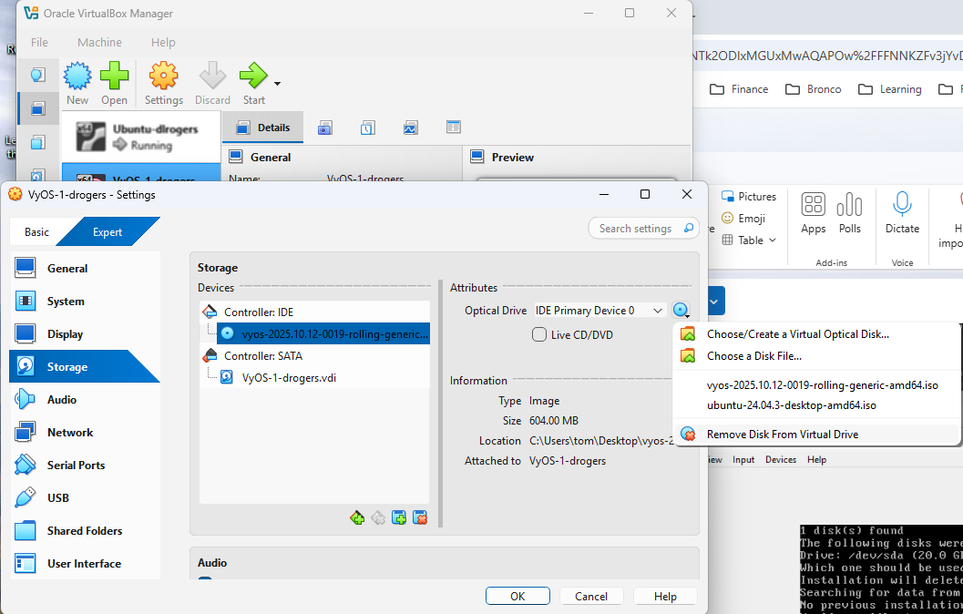
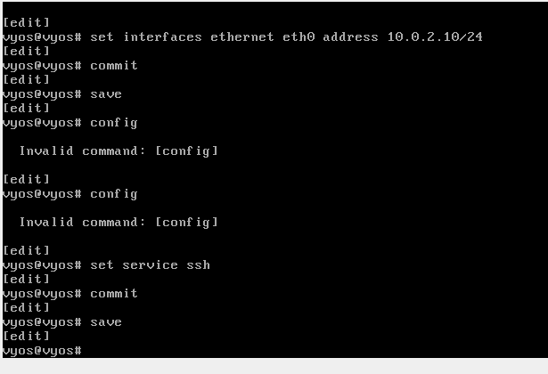
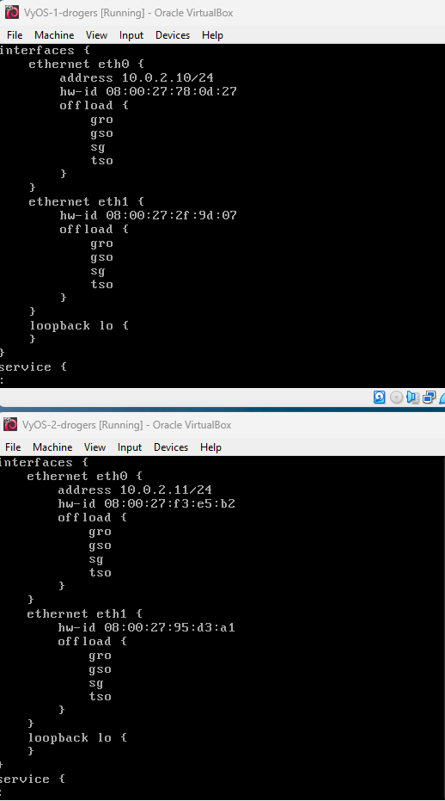
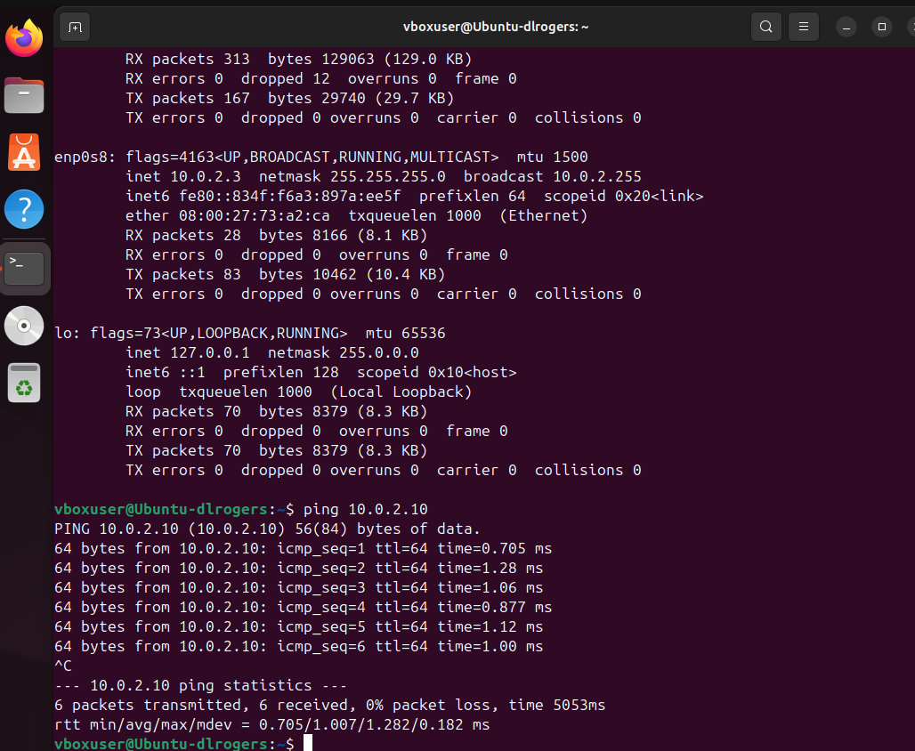
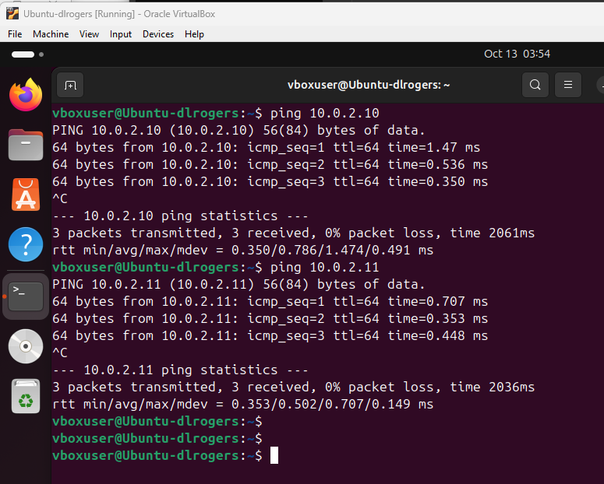



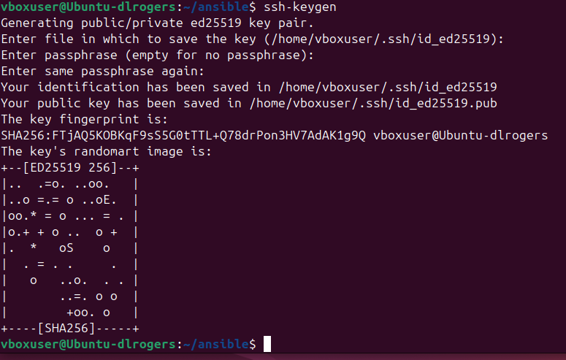

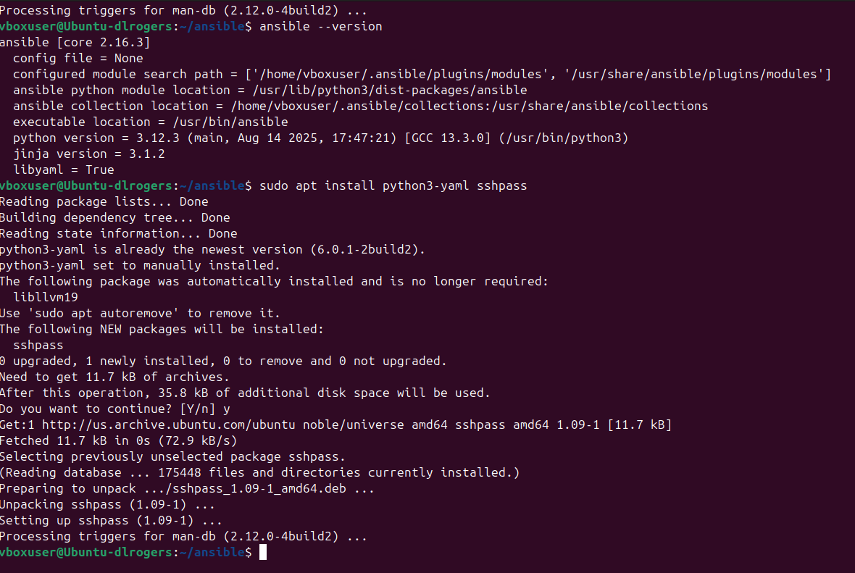
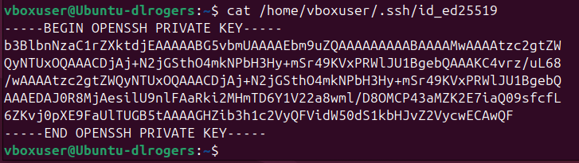
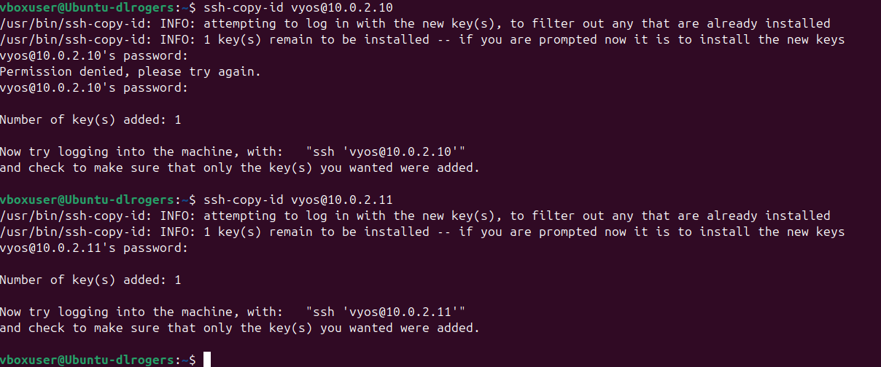

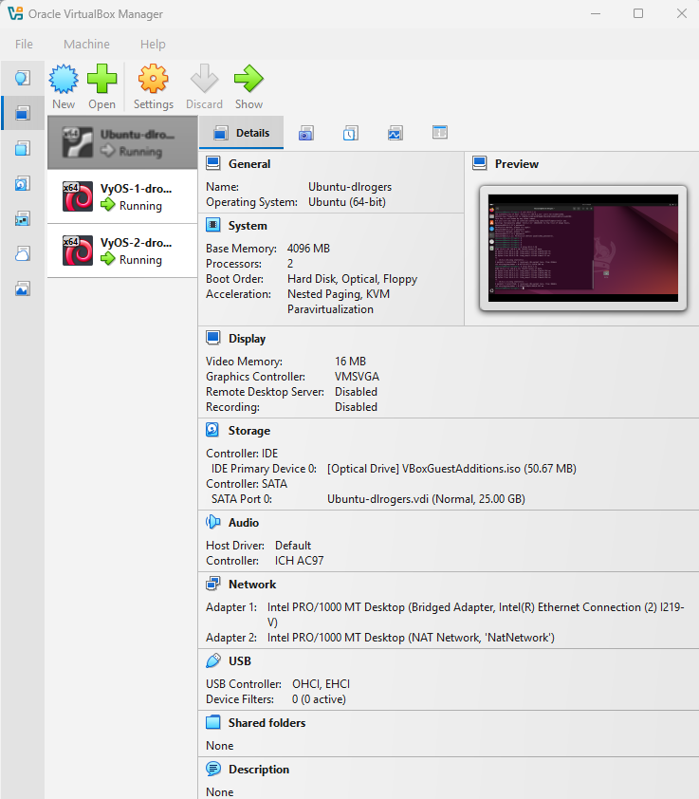

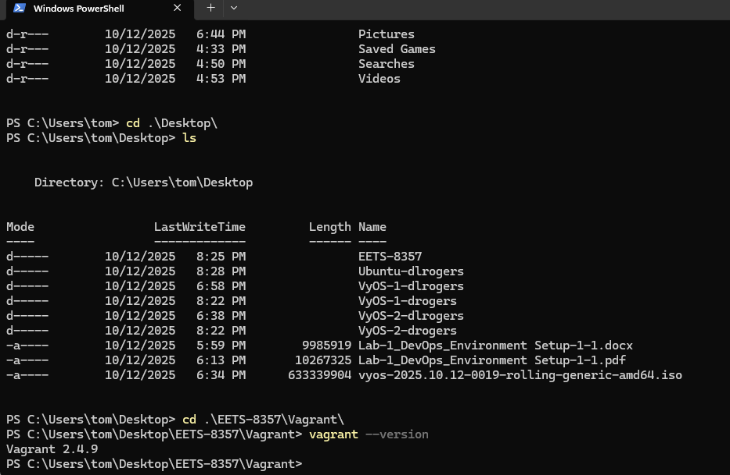
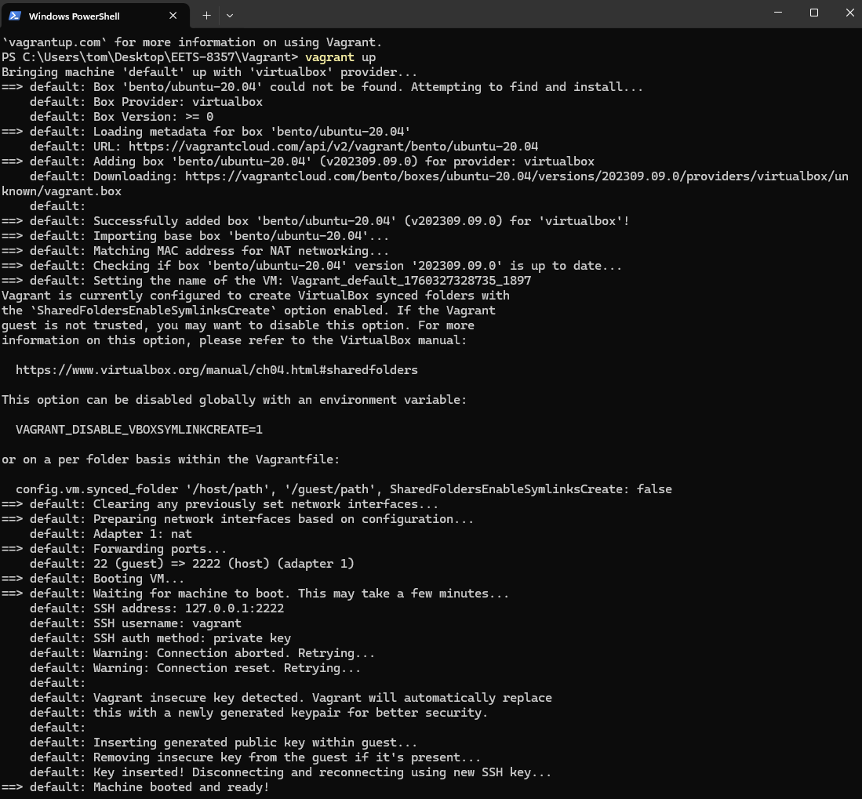

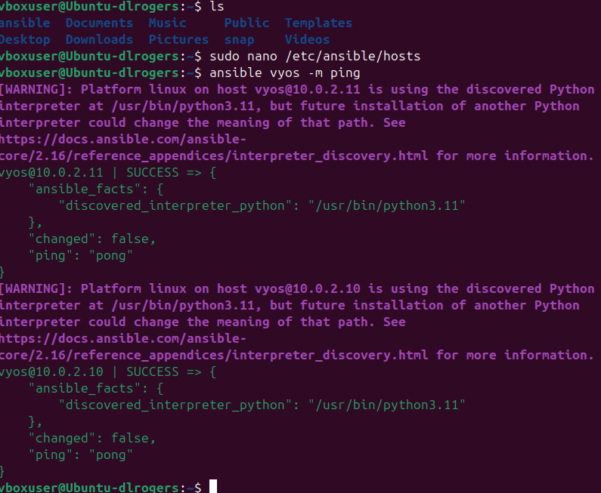

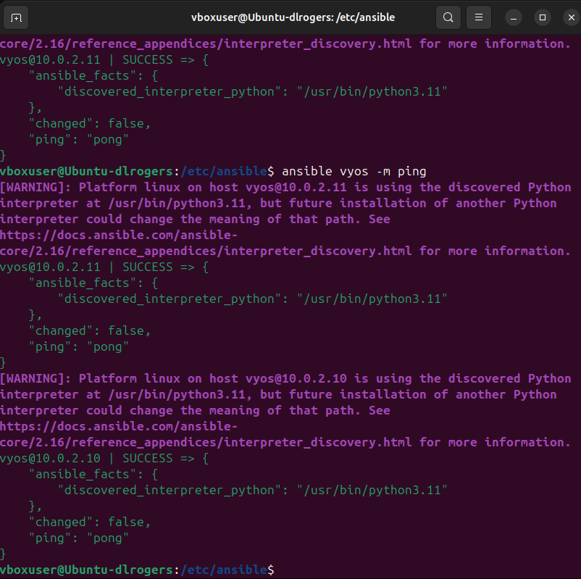

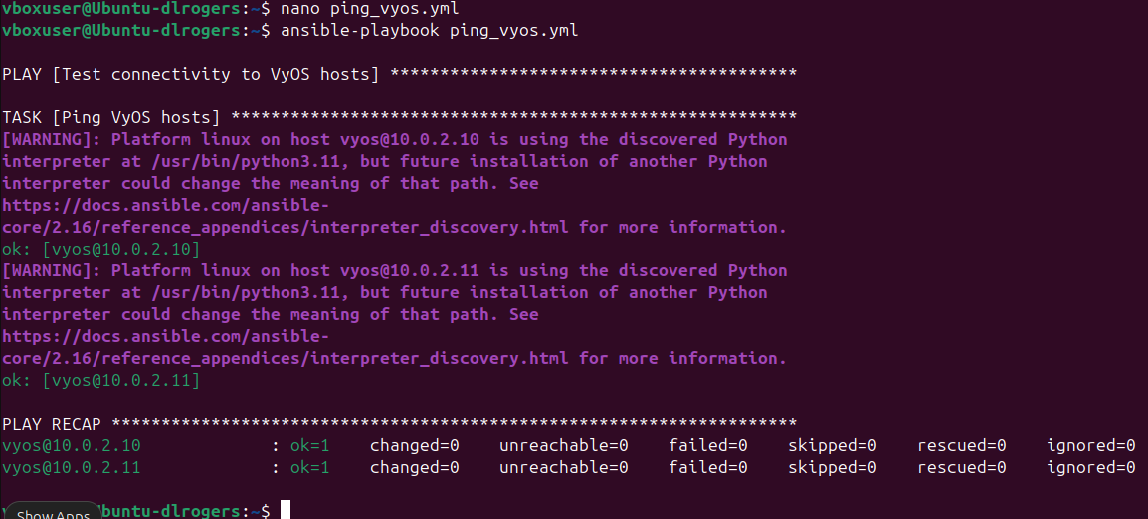
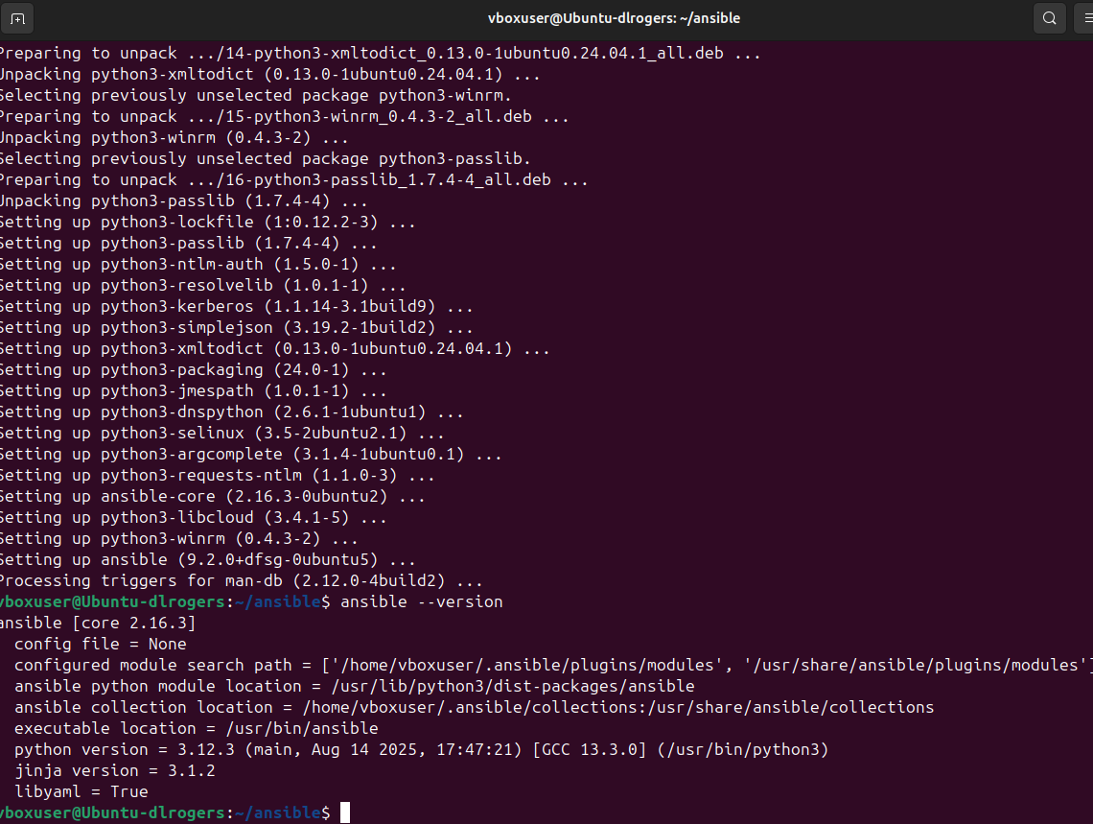

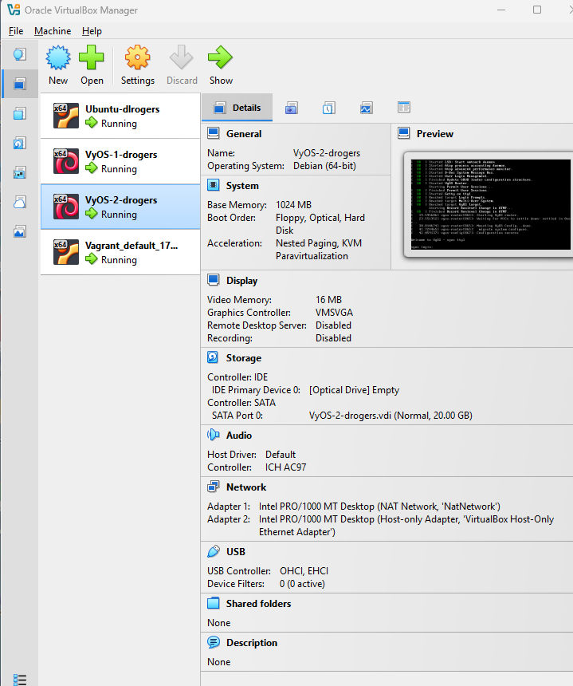

Lab Report
Wow! What a challenge! This lab tied together lots of questions about what things are.
For this semester I finally gave in and obtained a used Dell desktop computer and did a bare metal install using Windows 11. The previous two semesters I have attempted to use Apple Mac Mini Desktops with my 60 terabyte NAS and virtualization to create my lab environment. I now have a legit bare metal Windows lab machine with Oracle VirtualBox and all the VMs are up and communicating!!
Getting the base Windows OS setup and VirtualBox were pretty straight forward. I have never heard of nor used SyOS as a virtual router platform which is what it seems to be? Of course, Ubuntu is a staple for us old network guys and it is familiar. I was not familiar with the “Guest Edition CD Image” and am still unsure of what value it provides?
Installing and setting up the VyOS was surprisingly straight forward for an open-source software that has brightly lit warnings about NOT being used for production environments. No glitches. No breaks. Using the ISO to install and then cutting it loose and configuring went pretty much as planned. I had a few questions when it came to setting up the hosts file but was able to work through those with a bit of Linux logic. I name the list [vyos] and placed it in the /etc/ansible/ directory for ansible to communicate with the file and pointers.
Having very little exposure to ansible I was pleased to learn that it is YAML based. I have used YAML with Python for the past two years, so I have some exposure. So, the first playbook was very easy and successful!!
Overall, I am very excited to have this lab built and it 100% works without any special needs! It was challenging and provided a great first level view of what each of these tools do and how they interact!

